Once Lost, Now Found: A Retrieval and Claim Tracking System for Misplaced Items



A Final Project Presented to
the Faculty of the Institute of Computing,
Davao del Norte State College,
New Visayas, Panabo City

Abella, Rochelle D.
Piamonte, Ashley D.
Robles, Erika Leen M.

December 2025

Table of Contents

CHAPTER 1
INTRODUCTION
Background of the System 3
Objectives 4
Flowchart 5
Pseudocode 7
Code 14

CHAPTER II
RESULT AND DISCUSSION
Result 24
Discussion 28

CHAPTER III
CONCLUSION AND RECOMMENDATION
Conclusion 29
Recommendation 29

REFERENCES 31

CHAPTER I
INTRODUCTION
- Background of the System
In today's academic institutions, the number of students, staff, and everyday activities grows, increasing the chance of personal things being forgotten on the college campus. Mobile phones, ID cards, wallets, and keys are among the many misplaced items that can be challenging to retrieve because of outdated and disorganized reporting procedures. Schools that use verbal communication, handwritten documents, or bulletin boards frequently deal with issues like slow item recovery, missing records, and insufficient information. These problems highlight the need for a better organized, easily accessible, and effective system that makes it easier for people to report, handle, and retrieve misplaced objects.
Moreover, in order to address this issue, the team created a console-based Java Lost and Found System that was paired with JOptionPane to offer a straightforward but well-organized digital solution. The system enables users to sign up, log in safely, and access an item control main menu. The program stores all entries in a 2D array, assigning each item fields like name, description, contact, type, and claim status. Each user can add a complete record of lost or found items, including the item name, description (location and time), contact information, and classification as either "Lost" or "Found." Users can view all recorded items, change item statuses by designating them as "Claimed," and remove entries as needed through the main menu. By preventing problems like duplicate usernames, empty fields, invalid item kinds, and wrong item numbers, built-in validations guarantee accurate and efficient user interaction with the system.
The system has limitations despite its beneficial characteristics. Only five user accounts and five item records can be saved at once because it makes use of fixed arrays. All data is temporary and vanishes when the application is closed due to the lack of a database or file handling. Nevertheless, the system offers an organized, effective alternative for traditional manual approaches and illustrates the key elements of digital record-keeping.

Globally, lost and found systems are crucial in assisting people in finding missing objects, particularly in public buildings and educational environments. Due to human error, out-of-date information, and a lack of centralization, traditional manual methods—such as paper records, bulletin boards, and informal communication—often lead to slow and unreliable recovery processes [1]. When schools and colleges use these techniques, they often run into issues including missing data, overlapping reports, and trouble confirming item ownership, which eventually irritates staff and students [2].
This issue has been recognized in a number of establishments, such as Zayed University, where the lack of a digital lost and found system results in inefficient operations and unorganized tracking of misplaced items [3]. In response, a lot of educational settings have switched to digital alternatives in order to increase accessibility and accuracy. Research has demonstrated that, when compared to manual approaches, even entry-level digital systems greatly reduce errors, improve organization, and increase user happiness [4]. Universiti Tun Hussein Onn Malaysia's (UTHM) digital Lost and Found platform, which replaced unofficial routes of communication with a centralized and organized system to enhance reporting and item matching, is an effective example [5].
To sum up, the Java-based console Lost and Found System seeks to provide a useful, well-organized, and convenient way to handle misplaced objects in educational settings. The system improves accuracy, efficiency, and convenience by digitizing the reporting and tracking process. It also illustrates basic programming concepts that are applicable in both academic and practical contexts.
- Objectives
The goal of this program is to create basic CRUD operations for Once Lost, Now Found: A Retrieval and Claim Tracking System for Misplaced Items. Specifically, it aims to:
- Allow the user to sign up/log in to the system of lost and found items.
- Allow the user to add the following information in the main menu:
  - Item Name (Console)
  - Item Description (Console)
  - Contact Information (Console)
  - Item Type (JOptionPane)
- Allow the user to view information in the lost and found system.
- Allow the user to update information about the lost and found items.
- Allow users to delete information in the lost and found items.
- Allow the user to log out in the main menu.
- Allow the user to exit the program.

- Flowchart
Sign-Up Process
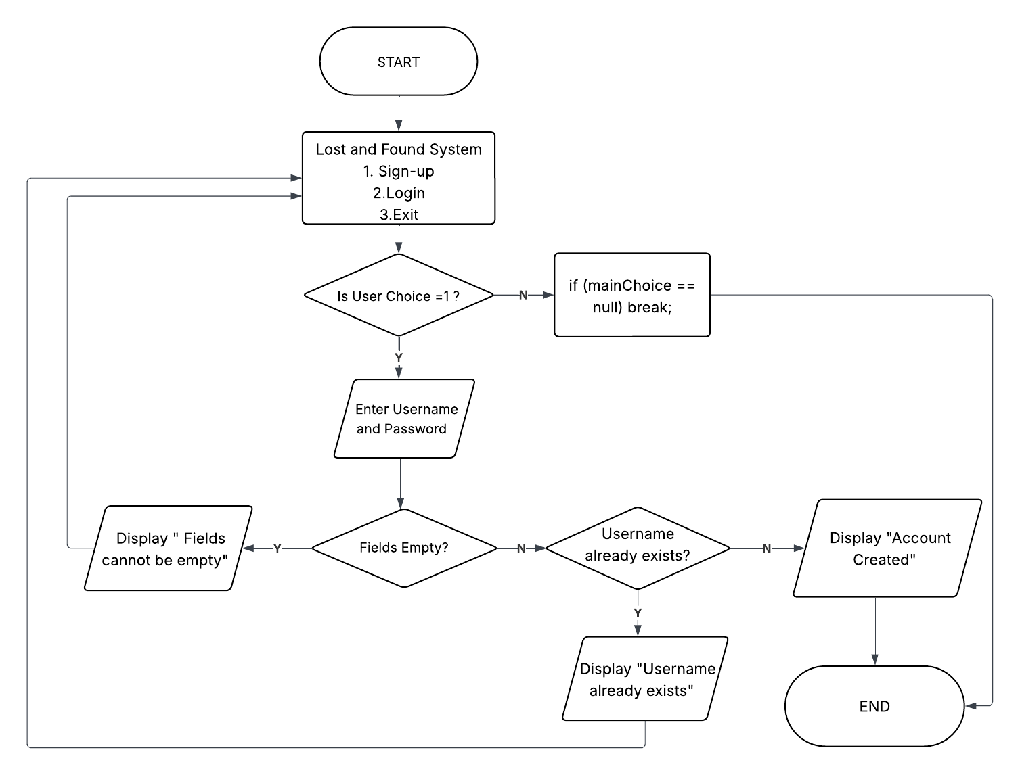
Figure 1 illustrates the sign-up process of the Lost and Found System. The process begins with a menu where the user selects the Sign-Up option. The system then prompts for a username and password, checks for empty fields, and verifies whether the username already exists. If all conditions are met, it creates the account. Otherwise, it displays the appropriate error message and returns the user to the menu or ends the process.
Figure 1. Sign-up Process
Login Process
Figure 2 shows the login process of the system. When a user selects the Login option, they are prompted to enter their username and password; then the system validates the credentials and either grants access with a “Login Successful” message or displays “Invalid Credentials” if the login fails. Once logged in, the user is taken to the Main Menu, where they can choose to Add Item, View Items, Update (claim), Delete Items, and Log Out. Each menu choice leads to its own process, with the system checking for valid input before continuing. The Main Menu serves as the primary navigation for all user actions within the Lost and Found System.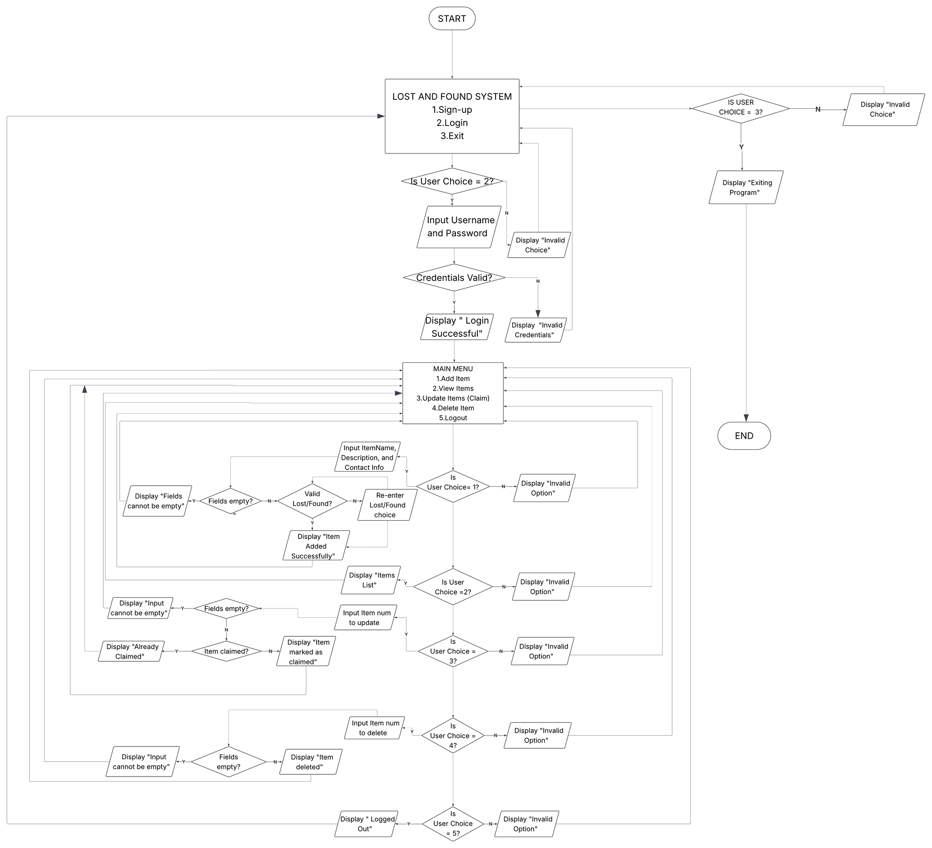
Figure 2. Login Process

Exit Process
Figure 3 illustrates the exit process of the Lost and Found System. The process begins when the user selects the Exit option. When this option is chosen, the system displays the message “Exiting Program,” then closes the Scanner resource and immediately terminates the program. Otherwise, it presents an “Invalid Choice” message and returns the user to the Sign-up, Login, and Exit processes of the Lost and Found System.
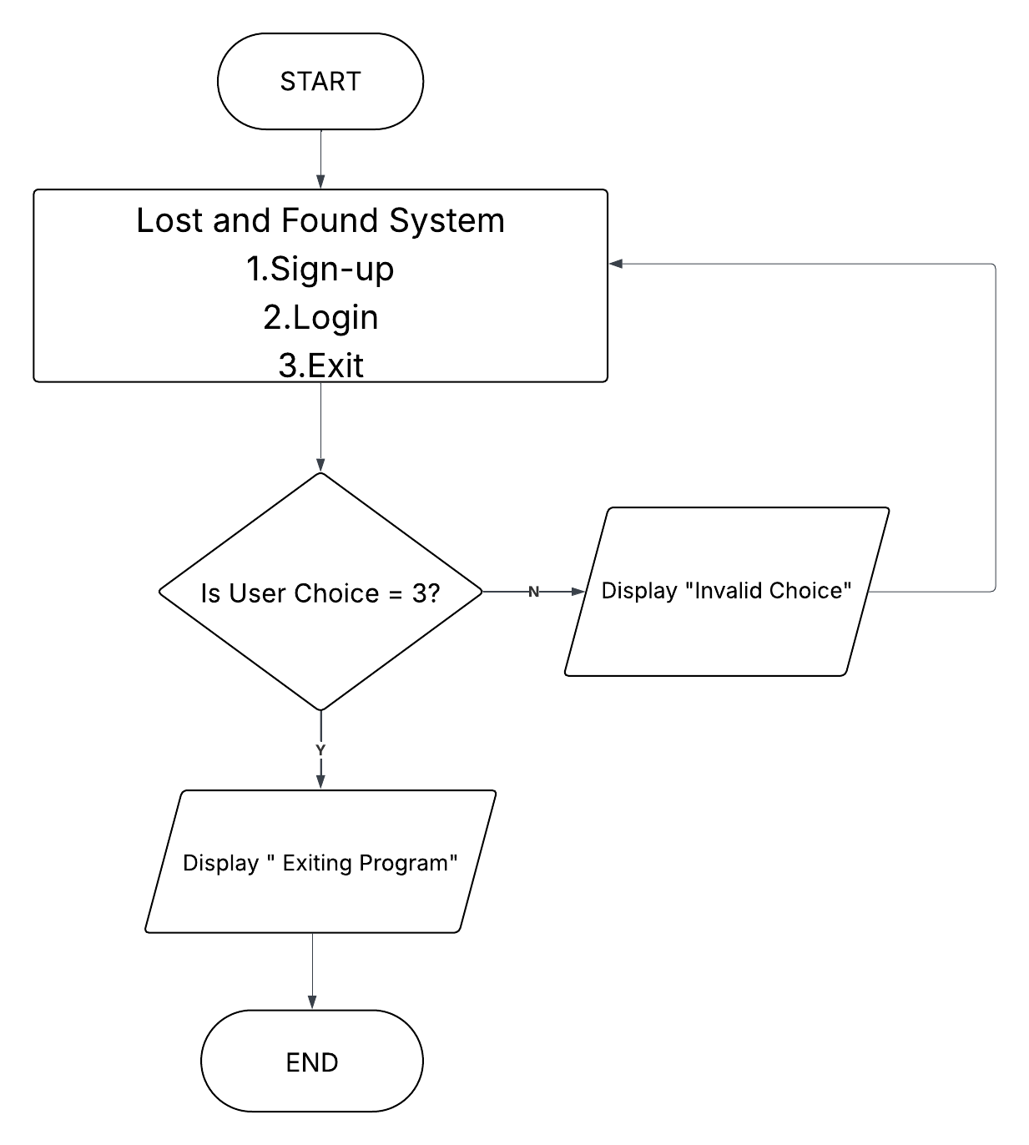

Figure 3. Exit Process
- Pseudocode
1. Sign Up Process

START
REPEAT
DISPLAY “LOST & FOUND SYSTEM”
DISPLAY “[1] SIGN-UP”
DISPLAY “[2] LOGIN”
DISPLAY “[3] EXIT”
INPUT mainChoice
IF mainChoice == 3 THEN
BREAK
END IF
IF mainChoice == 1 THEN
// - - - SIGN-UP PROCESS - - -
DISPLAY “Enter Username: ”
INPUT username
DISPLAY “Enter Password: ”
INPUT password
IF username == ““ OR password == ”” THEN
DISPLAY "Fields cannot be empty”
CONTINUE
END IF
IF username already exists in database THEN
DISPLAY “Username already exists”
CONTINUE
ELSE
Save username and password to database
DISPLAY “Account Created”
END IF
END IF
UNTIL FALSE
END

2. Log In Process
START
// - - - LOGIN PROCESS - - -
IF mainChoice == 2 THEN
DISPLAY "Enter Username:"
INPUT username

DISPLAY "Enter Password:"
INPUT password
IF credentials match database THEN
DISPLAY "Login Successful"
ELSE
DISPLAY “Invalid Credentials”
END IF
// - - - MAIN MENU (AFTER LOGIN) - - -
REPEAT
DISPLAY “MAIN MENU”
DISPLAY “[1] Add Item”
DISPLAY “[2] View Items”
DISPLAY “[3] Update (Claim) Item”
DISPLAY “[4] Delete Item”
DISPLAY “[5] Logout”
INPUT menuChoice

// - - - ADD ITEM - - -
IF menuChoice == 1 THEN
DISPLAY "Enter Item Name:"
INPUT itemName

DISPLAY "Enter Description:"
INPUT itemDesc

DISPLAY "Enter Contact:"
INPUT contact

IF any field is EMPTY THEN
DISPLAY "Invalid Input"
ELSE
SAVE itemName, itemDesc, contact
DISPLAY "Item Added"
END IF
END IF

// - - - VIEW ITEMS - - -
IF menuChoice == 2 THEN
IF no stored items THEN
DISPLAY "No Items Found"
ELSE
DISPLAY all stored items
END IF
END IF
// - - - CLAIM ITEM - - -
IF menuChoice == 3 THEN
DISPLAY "Enter Item Number to Claim:"
INPUT itemNum

IF itemNum exists THEN
UPDATE item status to CLAIMED
DISPLAY "Item Claimed Successfully"
ELSE
DISPLAY "Item Not Found"
END IF
END IF
// - - - DELETE ITEM - - -
IF menuChoice == 4 THEN
DISPLAY "Enter Item Number to Delete:"
INPUT itemNum
IF itemNum exists THEN
DELETE item from database
DISPLAY "Item Deleted"
ELSE
DISPLAY "Item Not Found"
END IF
END IF
// - - - LOGOUT - - -
IF menuChoice == 5 THEN
LoggedIn = false
DISPLAY "Logging Out..."
BREAK // exit logged-in main menu
END IF
UNTIL menuChoice == 5
ELSE
DISPLAY "Invalid Credentials"
END IF
CONTINUE
END IF
// - - - EXIT PROCESS - - -
IF userChoice = 3 THEN
DISPLAY “Exiting Program”
BREAK
ELSE
DISPLAY “Invalid Choice”
Go back to main menu
END IF
UNTIL FALSE
END
3. Exit Process
START

DISPLAY “Lost and Found System”
DISPLAY “1. Sign-up”
DISPLAY “2. Login”
DISPLAY “3. “Exit”
INPUT userChoice

IF userChoice = 3 THEN
Display “Exiting Program”
Terminate Program
ELSE
Display “Invalid Choice”
Go back to main menu
END IF
END
- Code - ABELLA
import java.util.Scanner;
import javax.swing.JOptionPane;

public class LostAndFound {
public static void main(String[] args) {

Scanner sc = new Scanner(System.in);

// USER STORAGE (1D Arrays)
String[] users = new String[5];
String[] passwords = new String[5];
int userCount = 0;

/*================================
ITEM STORAGE (2D ARRAY)
items[row][column]

Column Index:
[0] = Item Name
[1] = Description
[2] = Contact Info
[3] = Type (Lost/Found)
[4] = Status (Unclaimed/Claimed)
*/
String[][] items = new String[5][5];
int itemCount = 0;

boolean loggedIn = false;

// PROGRAM LOOP
while (true) {

String mainChoice = JOptionPane.showInputDialog(
"LOST & FOUND SYSTEM\n" +
"[1] SIGN UP\n" +
"[2] LOGIN\n" +
"[3] EXIT\n" +
"Choose:");

if (mainChoice == null) break;//cancel

switch (mainChoice) {

// SIGN UP SECTION
case "1":

if (userCount >= 5) {
JOptionPane.showMessageDialog(null, "Maximum users reached!");
break;
}

System.out.print("Enter username: ");
String newUser = sc.nextLine().trim();

// Check if username already exists
boolean exists = false;
for (int i = 0; i < userCount; i++) {
if (users[i].equalsIgnoreCase(newUser)) {
exists = true;
break;
}
}

if (exists) {
JOptionPane.showMessageDialog(null, "Username already exists!");
break;
}

System.out.print("Enter password: ");
String newPass = sc.nextLine().trim();

if (newUser.isEmpty() || newPass.isEmpty()) {
JOptionPane.showMessageDialog(null, "Fields cannot be empty!");
break;
}

users[userCount] = newUser;
passwords[userCount] = newPass;
userCount++;

JOptionPane.showMessageDialog(null, "Account created!");
break;

// LOGIN SECTION
case "2":

String u = JOptionPane.showInputDialog("Enter Username:");
String p = JOptionPane.showInputDialog("Enter Password:");

boolean found = false;
int currentUser = -1;

// Validate credentials
for (int i = 0; i < userCount; i++) {
if (users[i].equals(u) && passwords[i].equals(p)) {
found = true;
loggedIn = true;
currentUser = i;
break;
}
}

if (!found) {
JOptionPane.showMessageDialog(null, "INVALID CREDENTIALS!");
break;
} else {
JOptionPane.showMessageDialog(null, "LOGIN SUCCESSFUL!");
}

// ================================
// MAIN MENU (AFTER LOGIN)
// ================================
while (loggedIn) {

String menuChoice = JOptionPane.showInputDialog(
"===== MAIN MENU =====\n" +
"[1] ADD ITEM\n" +
"[2] VIEW ITEMS\n" +
"[3] UPDATE ITEM (CLAIM)\n" +
"[4] DELETE ITEM\n" +
"[5] LOGOUT\n" +
"Choose:");

if (menuChoice == null) break;//cancel

switch (menuChoice) {

// ADD ITEM
case "1":

if (itemCount >= 5) {
JOptionPane.showMessageDialog(null, "Cannot add more items!");
break;
}

System.out.print("Item Name: ");
String name = sc.nextLine().trim();
System.out.print("Description (Location and Time): ");
String desc = sc.nextLine().trim();
System.out.print("Contact Info: ");
String contact = sc.nextLine().trim();

if (name.isEmpty() || desc.isEmpty() || contact.isEmpty()) {
JOptionPane.showMessageDialog(null, "Fields cannot be empty!");
break;
}

String type;
do {
type = JOptionPane.showInputDialog("Type (Lost/Found):");

if (type == null) break;

if (!type.equals("Lost")&& (!type.equals("Found"))) {

JOptionPane.showMessageDialog(null,
"Invalid type!");
type = null;
}

} while (type == null);

items[itemCount][0] = name;
items[itemCount][1] = desc;
items[itemCount][2] = contact;
items[itemCount][3] = type;
items[itemCount][4] = "Unclaimed";

itemCount++;

JOptionPane.showMessageDialog(null, "Item added successfully!");
break;

// VIEW ITEMS
case "2":

if (itemCount == 0) {
JOptionPane.showMessageDialog(null, "No items recorded.");
} else {
String list = "======== ITEMS LIST ========\n\n";

for (int i = 0; i < itemCount; i++) {

list += "----------------- ITEM # " + (i + 1) + "-----------------"+ "\n" +
"Name: " + items[i][0] + "\n" +
"Description: " + items[i][1] + "\n" +
"Contact: " + items[i][2] + "\n" +
"Type: " + items[i][3] + "\n" +
"Status: " + items[i][4] + "\n\n";
}

JOptionPane.showMessageDialog(null, list);
}
break;

// UPDATE ITEM STATUS (CLAIM)
case "3":

if (itemCount == 0) {
JOptionPane.showMessageDialog(null, "No items to update.");
break;
}

String updateItem = JOptionPane.showInputDialog("Enter item number to claim:");

if (updateItem == null || updateItem.isBlank()) {
JOptionPane.showMessageDialog(null, "Input cannot be empty!");
break;
}

int up;

try {
up = Integer.parseInt(updateItem);
} catch (NumberFormatException e) {
JOptionPane.showMessageDialog(null, "Invalid input! Please enter a NUMBER.");
break;
}

if (up < 1 || up > itemCount) {
JOptionPane.showMessageDialog(null, "Invalid item number.");
} else if (items[up - 1][4].equals("Claimed")) {
JOptionPane.showMessageDialog(null, "Already claimed.");
} else {
items[up - 1][4] = "Claimed";
JOptionPane.showMessageDialog(null, "Item marked as CLAIMED.");
}

break;

// DELETE ITEM
case "4":

if (itemCount == 0) {
JOptionPane.showMessageDialog(null, "No items to delete.");
break;
}

String deleteItem = JOptionPane.showInputDialog("Enter item number to delete:");

if (deleteItem == null || deleteItem.isBlank()) {
JOptionPane.showMessageDialog(null, "Input cannot be empty!");
break;
}

int del;

try {
del = Integer.parseInt(deleteItem);
} catch (NumberFormatException e) {
JOptionPane.showMessageDialog(null, "Invalid input! Please enter a NUMBER.");
break;
}

if (del < 1 || del > itemCount) {
JOptionPane.showMessageDialog(null, "Invalid item number.");
} else {

// Shift items upward
for (int i = del - 1; i < itemCount - 1; i++) {
for (int j = 0; j < 5; j++) {
items[i][j] = items[i + 1][j];
}
}

itemCount--;
JOptionPane.showMessageDialog(null, "Item deleted.");
}

break;

// LOGOUT
case "5":
loggedIn = false;
JOptionPane.showMessageDialog(null, "Logged out.");
break;

default:
JOptionPane.showMessageDialog(null, "Invalid option.");
}
}

break;

case "3": // EXIT PROGRAM
JOptionPane.showMessageDialog(null, "Exiting Program!");
sc.close();
return;

default:
JOptionPane.showMessageDialog(null, "Invalid choice.");

}
}
}
}

CHAPTER II
RESULTS AND DISCUSSIONS

- Results
Figure 4 shows the sign-up and login interface, which allows users to create a new account by entering a username and password. The system checks for duplicate usernames and ensures that all required fields are completed before account creation. Once the information is valid and the username is unique, the account is successfully created, and the user can proceed to log in with the same credentials.
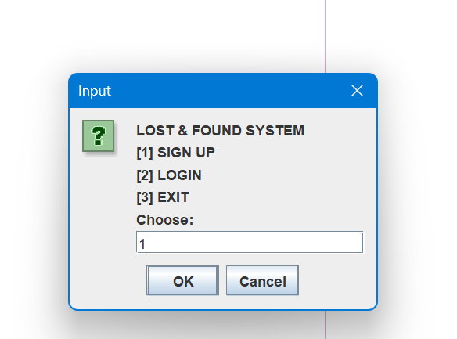
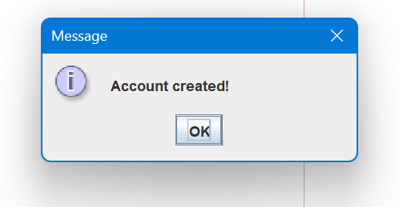
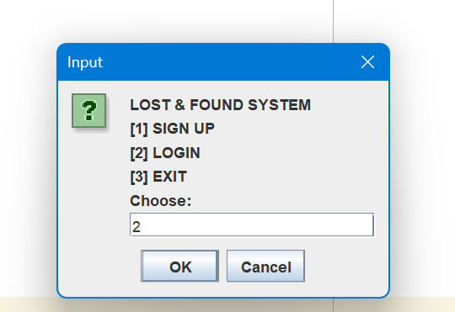
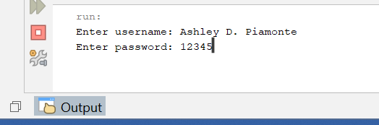
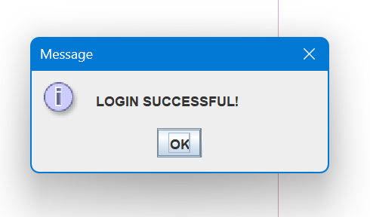
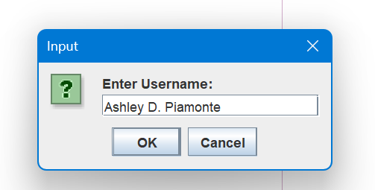
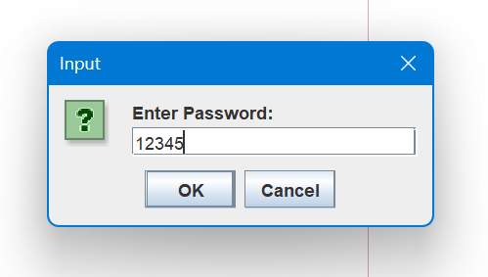

Figure 4. Sign Up & Login Interface

Figure 5 shows the Add Item Menu, which allows users to enter the following information: Item Name, Item Description, Contact Information, and Item Type. Once all required details are provided, the Item Information is successfully added to the system.

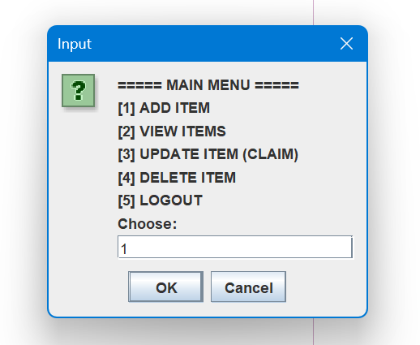
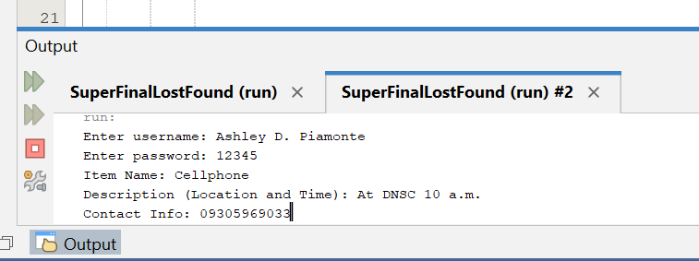
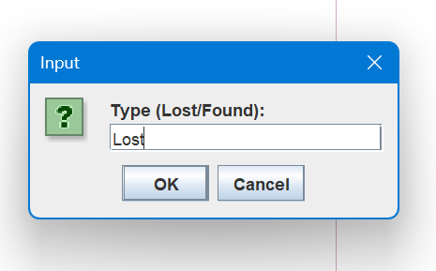
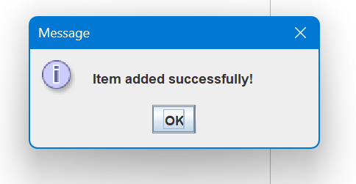

Figure 5. Add Item Interface
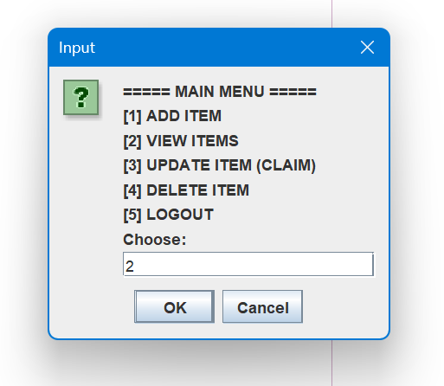
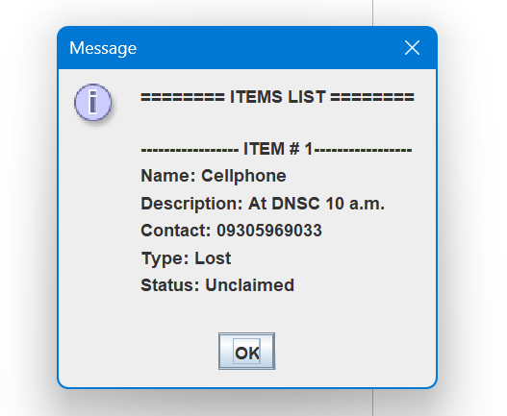
Figure 6 shows the View Items Menu, which allows users to see a list of all items recorded in the system. Each item’s name, description, contact information, type, and status are clearly displayed to help users track and identify lost or found items.

Figure 6. View Items Interface
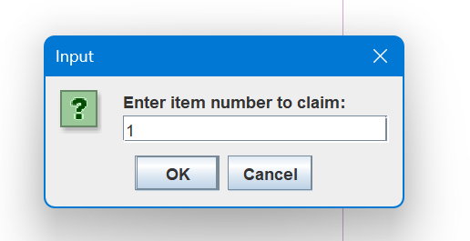
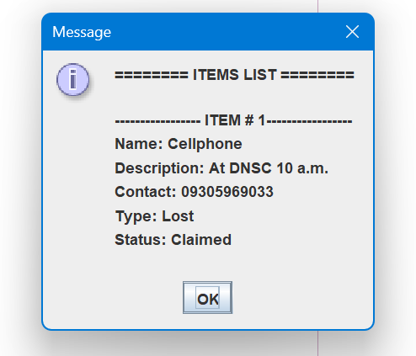
Figure 7 shows the Update Item (Claim) Menu, which allows the users to enter the number of a specific item they intend to claim. Once entered, the system updates the item’s status to “CLAIMED,” indicating that the item has been successfully claimed.
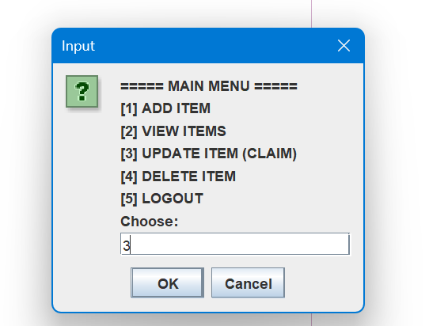
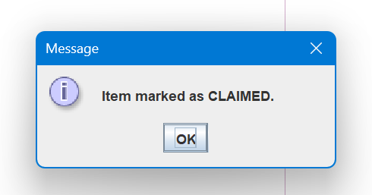

Figure 7. Update Item (Claim) Interface
Figure 8 shows the Delete Item Menu, which allows users to enter the number of a specific lost or found item they want to remove from the system. Once entered, the system deletes the selected item, and it no longer appears in the View Items List.
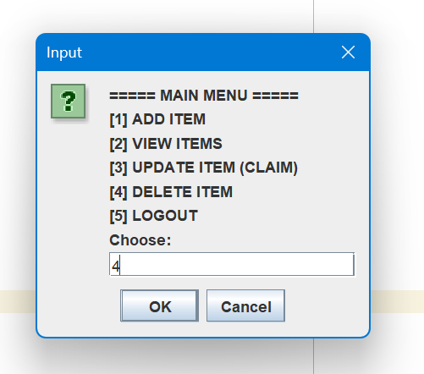
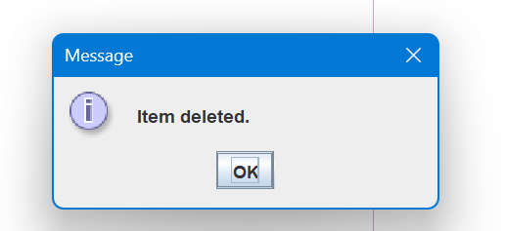
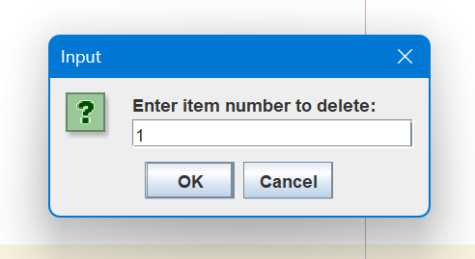

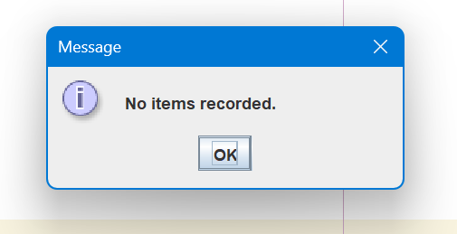
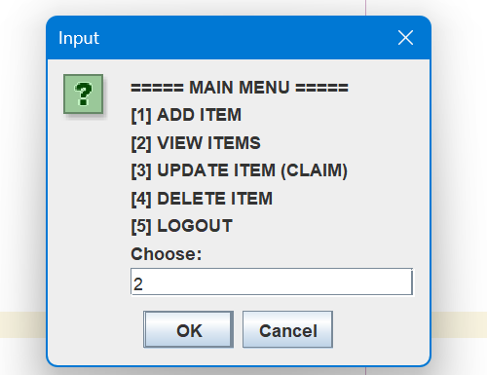

Figure 8. Delete Item Interface

Figure 9 shows the Logout Menu, which allows the user to log out from the main menu. Once selected, the system ends the session and displays a confirmation message indicating that the user has successfully logged out.
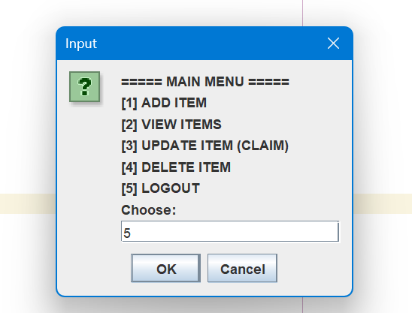
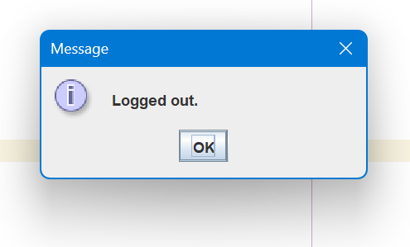

Figure 9. Logout Interface
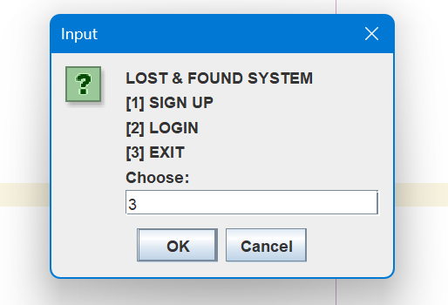
Figure 10 shows the Exit Interface, which allows the user to close the Lost and Found system. When the exit option is selected, the program terminates and the input scanner is closed. A message is then displayed to inform the user that the program is exiting successfully.
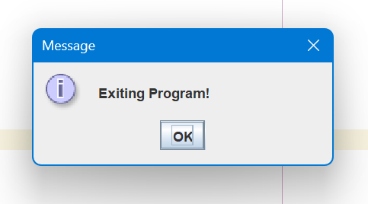

Figure 10. Exit Interface
- Discussions
During the development of the Lost and Found System, we realized how important it is to plan the system’s flow before starting the actual coding. According to Pressman and Maxim, using tools such as flowcharts and pseudocode helps developers better understand system requirements and structure before coding [10].

We also faced several challenges. One of the main issues was handling invalid user inputs, which sometimes caused errors in the program. We solved this by improving our input validation and giving clearer messages to guide the users. Another challenge was making sure the program exited properly, which required testing and adjusting our code.
Through these experiences, we learned the value of teamwork, communication, and regular testing. We also discovered that keeping our code clear and organized helps reduce mistakes. These lessons will guide us in making better and more efficient systems in future projects.

CHAPTER III
CONCLUSION AND RECOMMENDATION
- Conclusion
The development of the Lost and Found System showed that a structured digital approach is far more efficient than traditional manual methods such as paper logs and bulletin boards. It improved accuracy, organization, and efficiency in managing misplaced items [1]. The outcomes of the system development are an organized and efficient approach to managing lost and found records, smoother user transactions, accurate data handling, and more dependable system performance. All project objectives were successfully achieved. Users can sign up and log in to ensure secure access, add complete item details (item name, description, contact information, and item type), view, update (claim), and delete item records, and properly log out. The system also created a positive impact on students by offering an organized and user-friendly method for handling misplaced items.
Meanwhile, developers responsible for the Lost and Found System experienced reduced workload and improved record organization. There were challenges such as handling invalid inputs and ensuring proper program exit, but these were resolved through improved validation, clearer user prompts, and continuous testing. The Lost and Found System not only functions effectively but was developed through careful problem-solving and collaboration.
- Recommendation
- Implement a database system - the current program uses fixed-size arrays that cannot store data permanently. Databases provide scalability, persistent storage, and efficient data retrieval. Modern information systems rely heavily on database management systems for maintaining structured data, as discussed in [7].
- Add search and filtering features - allow users to quickly locate items based on type, status, date, or keywords. Jakob Nielsen’s usability framework emphasizes searchability and ease of use of user interfaces. His definition of “usability” includes efficiency and satisfaction—both of which tend to improve when users can easily locate items via search/filter rather than scan a long list [8].

- Introduce user roles such as Admin and Regular User - for better security and control. Admins should have access to all system functions, including deletion and updating, while regular users should be restricted to basic actions. This improves accountability and protects important data from accidental modification [9].

REFERENCES
[1] S. Kumar, D. Bhatnagar, D. Gahlot, B. S. Gola, and G. Rajput, “Web-Based Lost and Found System,” MIT Int. J. Comput. Sci. Inf. Technol., vol. 11, no. 1, 2022.
[2] Z. Salha and M. B. Pal, Mewar Lost and Found Information System, 2025.
[3] R. Shrivastava, M. Owais, M. Zaid, M. Noman, and M. Maaz, “Lost and Found Platform,” Int. J. Adv. Comput. Theory Eng., vol. 14, no. 1, pp. 284–288, 2025.
[4] E. Bataineh, B. Bataineh, and S. A. Kindi, “Design, development and usability evaluation of an online web-based lost and found system,” Int. J. Digit. Inf. Wireless Commun., vol. 5, pp. 75–81, 2015.
[5] T. Meshram et al., “Lost and Found Item Recovery System,” IJRASET J. Res. Appl. Sci. Eng. Technol., 2025.
[6] N. F. Shahzan and N. Arbaiy, “UTHM Lost and Found Management System,” Appl. Inf. Technol. Comput. Sci., vol. 6, no. 1, pp. 2307–2319, 2025.
[7] F. Strickland, “Chapter 3 Characteristics and Benefits of a Database,” Database Design – 3rd Edition.
[8] J. Nielsen, “10 Usability Heuristics for User Interface Design,” Nielsen Norman Group, Feb. 20, 2024.
[9] O. M. Dada, F. S. Adedotun, O. Oyedepo, and A. K. Raji, “Leveraging Role-Based Access Control for Secure and Efficient Result Processing in Academic Environments,” SJESTP, Nov. 9, 2024.
[10] R. Pressman and B. Maxim, Software Engineering: A Practitioner’s Approach, 8th ed. New York, NY, USA: McGraw-Hill, 2015.

